##### A Project report on

**Creating Realistic Novel Images through Generative Neural Networks (GAN)**

###### A Dissertation submitted to JNTU Hyderabad in partial fulfillment of the academic requirements for the award of the degree.

**Bachelor of Technology**

**in**

**Computer Science and Engineering**

Submitted by

M.YASHWANTH

(20H51A05C8)

N.KOUSHIK

(20H51A05G2)

P.ANUSHA

(20H51A05J3)

Under the esteemed guidance of

**Mr. T. UPENDER**

**Assistant Professor**

**CSE**



**Department of Computer Science and Engineering**

**CMR COLLEGE OF ENGINEERING & TECHNOLOGY**

(UGC Autonomous)

*Approved by AICTE *Affiliated to JNTUH *NAAC Accredited with A+ Grade

KANDLAKOYA, MEDCHAL ROAD, HYDERABAD - 501401.

#### 2020- 2024

**CMR COLLEGE OF ENGINEERING & TECHNOLOGY**

KANDLAKOYA, MEDCHAL ROAD, HYDERABAD – 501401

**DEPARTMENT OF COMPUTER SCIENCE AND ENGINEERING**



#### CERTIFICATE

This is to certify that the Major Project Phase I report entitled **" Creating Realistic Novel Images through Generative Neural Networks (GAN) "** being submitted by M. YASHWANTH (20H51A05C8), N. KOUSHIK (20H51A05G2), P. ANUSHA (20H51A05J3) in partial fulfillment for the award of **Bachelor of Technology in Computer Science and Engineering** is a record of bonafide work carried out his/her under my guidance and supervision.

###### The results embodies in this project report have not been submitted to any other University or Institute for the award of any Degree.

**Mr. T. Upender Dr. Siva Skandha Sanagala**

**Assistant Professor Associate Professor and HOD**

**Dept. of CSE Dept. of CSE**

#### ACKNOWLEDGEMENT

With great pleasure we want to take this opportunity to express my heartfelt gratitude to all the people who helped in making this project work a grand success.

We are grateful to **Mr. T. Upender,** Assistant Professor, Department of Computer Science and Engineering for his valuable technical suggestions and guidance during the execution of this project work.

We would like to thank **Dr. Siva Skandha Sanagala,** Head of the Department of Computer Science and Engineering, CMR College of Engineering and Technology, who is the major driving forces to complete my project work successfully.

We are very grateful to **Dr. Vijaya Kumar Koppula**, Dean-Academics, CMR College of Engineering and Technology, for his constant support and motivation in carrying out the project work successfully.

We are highly indebted to **Major Dr. V A Narayana,** Principal, CMR College of Engineering and Technology, for giving permission to carry out this project in a successful and fruitful way.

We would like to thank the **Teaching & Non- teaching** staff of Department of Computer Science and Engineering for their co-operation

We express our sincere thanks to **Shri. Ch. Gopal Reddy**, Secretary, CMR Group of Institutions, for his continuous care.

Finally, We extend thanks to our parents who stood behind us at different stages of this Project. We sincerely acknowledge and thank all those who gave support directly and indirectly in completion of this project work.

M.YASHWANTH 20H51A05C8

N. KOUSHIK 20H51A05G2

P. ANUSHA 20H51A05J3

**Creating Realistic Novel Images through Generative Neural Networks (GAN)**

**TABLE OF CONTENTS**

**CHAPTER**

**NO. TITLE PAGE NO.**

LIST OF FIGURES ii

ABSTRACT iii

**1** **INTRODUCTION** 1-3

1.1 Problem Statement 2-3

1.2 Research Objective 2

1.3 Project Scope and Limitations 3

**2** **BACKGROUND WORK** 2-15

2.1. proposed solution

2.1.1 Merits 13 2.2. Existing solutions 14-15

**3 RESULTS AND DISCUSSION**  16-21 3.1. Performance metrics 17-18

4 **CONCLUSION**

5.1 Conclusion 22-23

**REFERENCES** 24-25

**GitHub Link 25**

CMRCET B. Tech (CSE) Page No i

**Creating Realistic Novel Images through Generative Neural Networks (GAN)**

**List of Figures**

**FIGURE**

**NO. TITLE PAGE NO.**

1.1 Machine Learning prediction model 15

1.2 Note Book 21

CMRCET B. Tech (CSE) Page No ii

**Creating Realistic Novel Images through Generative Neural Networks (GAN)**

# **ABSTRACT**

The "Generative Neural Networks for Novel Image Generation" project aims to expand

creative & generative capabilities of neural networks beyond traditional discriminative models. In previous contexts, neural networks have primarily utilized for tasks involving input-to-output mappings, such as image classification and text generation. However, this project delves into the realm of generative models, where the focus shifts from making decisions to creating entirely new and unique creative content.

At its core, the project equips neural networks with the power to craft images that encapsulate the style and essence of existing training data. This synthesis of new, yet familiar, visuals introduce diversity and creativity. Beyond artistic, the project holds practical value in data augmentation, offering a solution to data scarcity by generating synthetic content that can enhance machine learning model performance.

The impact of this project extends across industries. In healthcare, it assists medical image analysis by generating realistic data for algorithm training. In fashion, it aids design by creating new patterns and styles.

The project also addresses data privacy concerns, enabling information sharing without compromising sensitive details. By forging a bridge between technology and creativity, the "Generative Neural Networks for Novel Image Generation" project innovation, enriches data science.

Moreover, the project underscores the significance of synthetic data in addressing data scarcity and privacy concerns. Synthetic data has the potential to supplement real datasets in scenarios where access to authentic data is limited or protected.

CMRCET B. Tech (CSE) Page No iii

**Creating Realistic Novel Images through Generative Neural Networks (GAN)**

# **CHAPTER 1**

**INTRODUCTION**

CMRCET B. Tech (CSE) Page No 1

**Creating Realistic Novel Images through Generative Neural Networks (GAN)**

**CHAPTER 1**

**INTRODUCTION**

* 1. **Problem Statement**

The field of neural networks has predominantly focused on discriminative models, which excel at tasks involving input-to-output mappings like image classification and text generation. While these models have achieved remarkable success in decision-making tasks, there remains a significant gap in their creative capabilities. Existing neural networks are limited in their capacity to generate entirely novel and unique content. Consequently, there is a pressing need to push the boundaries of neural network capabilities by developing generative models that can go beyond mere decision-making and instead, create innovative and original content. The "Generative Neural Networks for Novel Image Generation" project aims to address this gap by exploring and advancing the potential of generative neural networks in the realm of creative content generation.

* Limitations of traditional discriminative models: Current neural networks lack the ability to generate diverse and creative visual content, hindering data augmentation and artistic expression.
* Insufficient methods for data augmentation: The absence of effective generative models limits the potential for enhancing machine learning model performance through synthetic content generation.
* Practical applications in industries: The project addresses the need for generating new patterns, styles, and realistic data in industries such as healthcare and fashion.
* Bridging technology and creativity: The project aims to bridge the gap between technology and creativity by developing innovative approaches for generative image generation using neural networks.

"Novel" refers to something that is new, original, or innovative. In the context of the project description you provided, "novel images" are images that have not been seen before in the training dataset but are generated by a neural network to closely resemble the characteristics and patterns of the training images. These generated images are unique and creative.

CMRCET B. Tech (CSE) Page No 2

**Creating Realistic Novel Images through Generative Neural Networks (GAN)**

The "Generative Neural Networks for Novel Image Generation" project aims to expand the creative capabilities of neural networks beyond traditional discriminative models. In previous contexts, neural networks have primarily been utilized for tasks involving input-to-output mappings, such as image classification and text generation. However, this project delves into the realm of generative models, where the focus shifts from making decisions to creating entirely new and unique content.

The core objective of this project is to train neural networks to generate novel images that closely resemble a predefined set of training images. By learning the underlying distribution and patterns within the training data, the generative models acquire the ability to produce images that maintain the same stylistic and structural characteristics. This creative endeavor

introduces a level of innovation distinct from conventional applications, as it involves the

synthesis of visual content rather than making determinations based on existing data.

The generative images crafted through this project possess qualities of novelty and diversity, showcasing the model's capacity to envision variations that harmonize with the original data distribution. By extending the boundaries of neural network application, this project contributes to artistic expression, creative design, and data augmentation. The novel images serve as a testament to the model's ingenuity in capturing intricate details and crafting content that captures the essence of the training data.

* 1. **Research Objective**

The objective of the "Generative Neural Networks for Novel Image Generation" project is to explore and expand the creative and generative capabilities of neural networks beyond traditional discriminative models. The project aims to equip neural networks with the ability to generate entirely new and unique creative content by synthesizing images that encapsulate the style and essence of existing training data. By delving into the realm of generative models, the project shifts the focus from decision-making tasks to the creation of creative visual content.

CMRCET B. Tech (CSE) Page No 3

**Creating Realistic Novel Images through Generative Neural Networks (GAN)**

**CHAPTER 2**

**BACKGROUND WORK**

CMRCET B. Tech (CSE) Page No 4

**Creating Realistic Novel Images through Generative Neural Networks (GAN)**

**CHAPTER 2**

**BACKGROUND WORK**

The domain of the "Generative Neural Networks for Novel Image Generation" project primarily falls within the field of Computer Vision and Artificial Intelligence.

**Computer Vision**

The project involves training neural networks to understand and replicate visual patterns and characteristics from a set of training images. The generated images align with the style, structure, and features of the training data, showcasing the project's application in image generation and manipulation.

Computer vision is a multidisciplinary field of artificial intelligence (AI) and computer science that focuses on enabling computers to interpret and understand visual information from the world. It aims to replicate the remarkable ability of human vision, allowing machines to perceive, analyze, and make decisions based on visual data. Computer vision has a wide range of applications across various industries, including healthcare, autonomous vehicles, robotics, surveillance, and entertainment.

* **Facial recognition**: Identifying individuals through visual analysis.
* **Self-driving cars**: Using computer vision to navigate and avoid obstacles.
* **Robotic automation**: Enabling robots to perform tasks and make decisions based on visual input.
* **Medical anomaly detection**: Detecting abnormalities in medical images for improved diagnosis.
* **Sports performance analysis**: Tracking athlete movements to analyze and enhance performance.
* **Manufacturing fault detection**: Identifying defects in products during the manufacturing process.

CMRCET B. Tech (CSE) Page No 5

**Creating Realistic Novel Images through Generative Neural Networks (GAN)**

* **Agricultural monitoring**: Monitoring crop growth, livestock health, and weather conditions through visual data.

**Artificial Intelligence**

The project explores generative models, a subset of AI, which involves teaching machines to create content that resembles existing data. The generative neural network is a manifestation of AI's creative potential and ability to simulate human artistic expression.

Artificial Intelligence (AI) is a multidisciplinary field of computer science that aims to create machines, systems, or software that can perform tasks that typically require human intelligence. These tasks include reasoning, problem-solving, learning, perception, language understanding, and decision-making. AI has grown significantly in recent years and has found applications in a wide range of industries, from healthcare and finance to transportation and entertainment.

Artificial Intelligence (AI) is a technology that enables machines to think and act like humans. AI is used in a variety of applications, such as natural language processing, computer vision, robotics, and machine learning. AI can be used to automate tasks, improve decision-making, and provide insights into data. Major vendors for AI technology include IBM, Microsoft, Google, Amazon, and Apple. These companies provide AI-based solutions for businesses, such as cloud-based AI services, AI-powered chatbots, and AI-driven analytics.

CMRCET B. Tech (CSE) Page No 6

**Creating Realistic Novel Images through Generative Neural Networks (GAN)**

Key Concepts in Artificial Intelligence:

Machine Learning: A subset of AI that focuses on the development of algorithms and statistical models that enable computers to learn from and make predictions or decisions based on data. Supervised learning, unsupervised learning, and reinforcement learning are common approaches in machine learning.

Deep Learning: A subfield of machine learning that utilizes neural networks with many layers (deep neural networks) to automatically learn and represent data. Deep learning has achieved remarkable success in image and speech recognition, natural language processing, and more.

Natural Language Processing (NLP): The branch of AI that deals with the interaction between computers and human language. NLP enables machines to understand, interpret, and generate human language, facilitating tasks like language translation, sentiment analysis, and chatbots.

Computer Vision: The field of AI that focuses on enabling computers to interpret and understand visual information from the world, similar to human vision. It plays a crucial role in applications like object recognition, image classification, and autonomous vehicles.

Robotics: Combining AI and robotics to create intelligent machines that can perceive their environment, make decisions, and perform physical actions. Robotics is used in manufacturing, healthcare, and more.

Reinforcement Learning: A type of machine learning where an agent learns to make decisions by interacting with an environment.

CMRCET B. Tech (CSE) Page No 7

**Creating Realistic Novel Images through Generative Neural Networks (GAN)**

**Data Science**

In the context of data science, the project emphasizes data augmentation through synthetic data generation. This technique has implications for improving model robustness and generalization, enhancing the quality of machine learning applications.

Data Science is a multidisciplinary field that uses scientific methods, algorithms, processes, and systems to extract knowledge and insights from structured and unstructured data. It combines expertise from various domains, including statistics, computer science, machine learning, and domain-specific knowledge, to solve complex problems and make data-driven decisions. Data science has gained immense importance in today's world as organizations recognize the value of data in gaining a competitive edge and making informed choices.

**Key Components of Data Science:**

Data Collection: Gathering data from various sources, which can include databases, sensors, web scraping, surveys, and more. Data can be structured (e.g., databases) or unstructured (e.g., text, images, and videos).

**Data Cleaning and Preprocessing:** Cleaning and transforming raw data to ensure it is accurate, consistent, and suitable for analysis. This process includes handling missing values, outliers, and data formatting.

**Exploratory Data Analysis (EDA):** Analyzing and visualizing data to discover patterns, relationships, and trends. EDA helps in understanding the data and formulating hypotheses for further analysis.

**Feature Engineering:** Selecting, creating, or transforming features (variables) to improve the performance of machine learning models. Feature engineering plays a crucial role in model accuracy.

CMRCET B. Tech (CSE) Page No 8

**Creating Realistic Novel Images through Generative Neural Networks (GAN)**

**Machine Learning**: Developing and training models to make predictions or classifications based on data. Supervised learning (e.g., regression, classification), unsupervised learning (e.g., clustering), and reinforcement learning are common approaches.

**Model Evaluation**: Assessing the performance of machine learning models using metrics like accuracy, precision, recall, F1-score, and others, depending on the specific task.

**Model Deployment**: Implementing models into production systems or applications for real-time predictions or decision support.

**Big Data Technologies**: Utilizing tools and frameworks like Hadoop and Spark to handle large-scale data processing and analysis.

**Data Visualization**: Creating visual representations of data to communicate findings effectively and aid in decision-making.

**Statistical Analysis**: Applying statistical methods to validate hypotheses, test significance, and draw conclusions from data.

**Domain Knowledge**: Incorporating expertise from the specific industry or domain to interpret results and provide context for data-driven decisions.

While the project has immediate applications in Computer Vision and AI, its outcomes and methodologies can extend to related domains such as digital art, design, and even certain aspects of machine learning, including data augmentation techniques.

CMRCET B. Tech (CSE) Page No 9

**Creating Realistic Novel Images through Generative Neural Networks (GAN)**

**2.1 DESCRIPTION OF THE PROJECT**

**1.CS231N Background:** CS231N refers to a course on Convolutional Neural Networks (CNNs) for Visual Recognition. It's likely a computer science or machine learning course that deals with understanding and implementing neural networks, especially CNNs, for tasks like image classification and analysis.

**2.Discriminative Models:** In the context of neural networks, discriminative models are those that are trained to make decisions about the input data. They take input and produce an output that is directly related to the input, such as class labels for images

**3.Generative Models:** Generative models, on the other hand, are designed to create new data that resembles a given dataset. Instead of just making decisions about data, generative models learn to generate new data points that resemble the training examples.

**4.Objective of the Notebook:** The notebook's objective is to introduce the concept of generative models using neural networks. Up until this point in the course, the focus has been on building discriminative models (like image classifiers) that provide labeled outputs. Now, the course is expanding its scope to cover generative models, where the goal is to create new data that shares similarities with the training data.

**5.Generating Novel Images**: The main focus of this project is to learn how to build neural network models that can generate new images. These images are created by the model in a way that they look like they belong to the same dataset that was used for training.

**6.Resemble Training Images**: The generated images should exhibit characteristics and patterns similar to the images used for training. In other words, the generative model should learn to capture the underlying distribution of the training data and produce images that fit within that distribution.

CMRCET B. Tech (CSE) Page No 10

**Creating Realistic Novel Images through Generative Neural Networks (GAN)**

**7.Novelty and Creativity:** This project introduces a new level of creativity and complexity compared to the earlier tasks in the course. Instead of just classifying or making decisions about input data, students will now be challenged to create entirely new data that follows the same style, structure, and features as the training data.

Overall, this notebook marks a transition from building models that classify or make decisions about data to models that have the ability to generate new, realistic data. It's a significant step toward understanding the broader applications of neural networks and machine learning, particularly in creative tasks like image generation.

**HOW THIS PROJECT IS HELPFUL IN MEDICAL SECTOR**

In the medical sector, the "Generative Neural Networks for Novel Image Generation" project can have several valuable applications and contributions

**Data Augmentation:** Medical imaging datasets are often limited due to privacy concerns and the challenges of obtaining real patient data. By generating synthetic medical images that closely resemble real patient cases, the project can augment these datasets, allowing for more comprehensive training of medical image analysis algorithms

**Algorithm Training and Testing:** The generated images can be used to train and test medical image analysis algorithms, such as those used for disease diagnosis, tumor detection, or anomaly identification. These algorithms benefit from exposure to diverse and realistic data, improving their accuracy and performance

**Rare or Unseen Cases:** Some medical conditions are rare or rarely encountered, making it difficult to collect sufficient data for training. The generative model can simulate these rare cases, enabling medical professionals to study and develop diagnostic tools

CMRCET B. Tech (CSE) Page No 11

**Creating Realistic Novel Images through Generative Neural Networks (GAN)**

**Privacy Preservation**: Patient data privacy is of utmost importance in the medical sector. The project helps address this concern by generating synthetic data that doesn't involve real patient information. This allows researchers and developers to work with data without compromising patient privacy

**Education and Training**: The generated medical images can be used in educational settings to train medical students, residents, and healthcare professionals. Simulated cases provide a safe environment for learning and practicing diagnostic skills

**Research and Development**: Medical researchers can use the generative model to create controlled experiments, investigate medical phenomena, and explore the behavior of medical imaging techniques under various conditions.

**Realistic Simulations**: The project can generate medical images with varying levels of pathology or conditions, providing a platform for simulating disease progression, treatment responses, and the effects of interventions

**Clinical Trials and Protocols**: Synthetic data can be utilized in the design and testing of new clinical trial protocols, aiding in the planning and assessment of medical interventions.

**Decision Support**: The generative model-generated images can serve as additional visual references for medical professionals, aiding in clinical decision-making and facilitating communication between specialists

By harnessing the power of generative neural networks, this project contributes to advancing medical imaging and analysis, fostering innovation, and enhancing the capabilities of medical professionals to diagnose, treat, and manage a wide range of health conditions

CMRCET B. Tech (CSE) Page No 12

**Creating Realistic Novel Images through Generative Neural Networks (GAN)**

**2.1.1 Advantages:**

**Data Augmentation:**

GNNs provide a powerful means to augment existing datasets. By generating synthetic images that closely resemble real data, it increases the diversity of training data for machine learning models, improving their generalization and performance.

**Addressing Data Scarcity:**

In scenarios where obtaining real data is challenging, expensive, or limited, GNNs can fill the data gap. This is particularly valuable in fields like medical imaging, where access to a large and diverse dataset can be difficult.

**Privacy-Preserving:**

GNNs allow for the generation of synthetic data that doesn't contain sensitive or private information. This is crucial in healthcare and other industries where privacy regulations are stringent.

**Creative Content Generation:**

GNNs enable the generation of creative and novel content, expanding the possibilities for artists, designers, and content creators. It can inspire new ideas and artistic expressions.

**Artificial Intelligence Training:**

For AI models, such as image classifiers and object detectors, GNN-generated images serve as a valuable resource for training and testing. They expose models to a wider range of data scenarios, making them more robust.

**Simulation:**

GNNs can simulate various scenarios, such as different weather conditions, architectural designs, or historical settings. This is valuable in fields like gaming, urban planning, and historical research.

CMRCET B. Tech (CSE) Page No 13

**Creating Realistic Novel Images through Generative Neural Networks (GAN)**

**2.2 HOW OUR PROJECT IS INNOVATIVE AND NEW FROM EXISTING SOLUTIONS**

The project of building a generative model for creating novel images introduces several new aspects compared to existing discriminative models or standard deep learning projects. Here's what's new and distinctive about this project:

**Generative Approach:** While many existing projects focus on discriminative models (e.g., image classification, object detection), this project delves into generative models. Instead of making decisions about input data, the goal is to generate entirely new data points that resemble the training data distribution.

**Creative Output:** The project emphasizes creativity and artistic generation. It goes beyond straightforward decision-making and involves creating new content with aesthetic qualities, making it suitable for applications like art, design, and content creation.

**Data Synthesis:** The project involves learning the underlying patterns and features of the training data and then synthesizing new data points based on that knowledge. This is different from standard tasks where models learn to recognize existing patterns in data.

**Novelty and Exploration:** The generated images are novel and unobserved in the original dataset. This opens up possibilities for exploration and expansion of the data space, allowing for creative exploration of what "could be" within the data distribution.

**Cross-Domain Applications:** The concept of generative models can be extended to other domains beyond images, such as text, audio, and video, leading to innovative cross-domain applications.

In summary, the project's novelty lies in its focus on generative capabilities, creativity, data synthesis, and the ability to explore and expand the data distribution space, which sets it apart from many existing projects centered around discriminative models and decision-making tasks.

CMRCET B. Tech (CSE) Page No 14

**Creating Realistic Novel Images through Generative Neural Networks (GAN)**

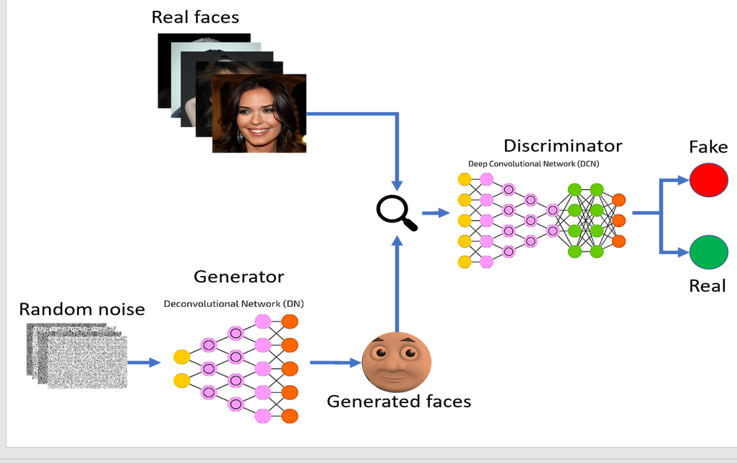

**Figure.1.1: Machine Learning Prediction Model**

CMRCET B. Tech (CSE) Page No 15

**Creating Realistic Novel Images through Generative Neural Networks (GAN)**

**CHAPTER 3**

**RESULTS AND DISCUSSION**

CMRCET B. Tech (CSE) Page No 16

**Creating Realistic Novel Images through Generative Neural Networks (GAN)**

**CHAPTER 3**

**RESULTS AND DISCUSSION**

Performance metrics:

The output from the project described above will be a generative model that can create novel images that resemble a set of training images. In other words, the goal of the project is to train a neural network to generate new images that share visual characteristics, patterns, and features with the images used for training.

Here's what the output will involve:

**1.Trained Generative Model:** The primary output of the project will be a trained neural network, specifically a generative model. This model will have learned the underlying distribution of the training images and will be capable of generating new images that follow a similar distribution.

**2.Generated Images:** Using the trained generative model, you will be able to generate new images that were not present in the original training dataset. These generated images will exhibit styles, textures, and structures similar to the images the model was trained on.

**3.Visual Quality and Realism:** The success of the project's output will be measured by the visual quality and realism of the generated images. The more realistic and indistinguishable from the training data these generated images are, the better the generative model has performed

**4.Diversity and Creativity:** A well-performing generative model will be able to produce diverse images that go beyond mere replication of the training examples. It should demonstrate creativity by generating variations and new instances that fit within the same style as the training images.

CMRCET B. Tech (CSE) Page No 17

**Creating Realistic Novel Images through Generative Neural Networks (GAN)**

**5.Evaluation Metrics:** In addition to the generated images, the project might also involve metrics for evaluating the performance of the generative model. Common metrics include perceptual similarity measures, pixel-wise comparisons, and user evaluations.

**6.Documentation and Code:** The project output will likely include well-documented code that implements the generative model, training procedures, and image generation process. Documentation is essential for others (and yourself) to understand and reproduce the project's results.

**7.Visual Demonstrations:** Presentation of generated images side by side with real training images can provide a visual demonstration of the model's effectiveness in capturing the essence of the training data and generating similar content.

Remember, the success of the project will be demonstrated by the ability of the generative model to produce high-quality, realistic, and creative images that convincingly resemble the training data distribution. The output of this project will showcase your understanding of generative models, deep learning techniques, and your ability to handle creative and complex tasks within the field of machine learning and computer vision.

The project of building a generative model for creating novel images has several practical applications in real-world problems across various domains. Here are some potential uses:

**Data Augmentation for Image Classification:** Synthetic data generated by the model can be used to augment training datasets for image classification tasks. This helps improve the performance and generalization of image classifiers, especially when real data is limited.

**Art and Creative Industries:** The generated images can be used by artists, designers, and creative professionals for inspiration, creating visual content, or generating new ideas for designs, illustrations, and artworks

CMRCET B. Tech (CSE) Page No 18

**Creating Realistic Novel Images through Generative Neural Networks (GAN)**

**Anomaly Detection:** The model can generate images representing normal data patterns. Any input data that deviates significantly from the generated images may be considered an anomaly, making it useful for anomaly detection tasks in various industries, such as manufacturing or security

**Medical Imaging:** Synthetic medical images can be used to supplement real medical datasets for training diagnostic models. This can help improve the robustness of medical image analysis algorithms

**Video Game Development:** Generated images can be used in video game development to create diverse in-game environments, characters, objects, and textures, reducing the need for manual design work

**Fashion and Retail:** Generated images can be used for virtual fashion design and showcasing clothing items on e-commerce platforms without the need for extensive photoshoots.

**Data Privacy:** Instead of sharing real user data, synthetic data can be shared for research purposes, protecting individual privacy while enabling analysis.

**Satellite and Aerial Imagery:** Generative models can be used to simulate satellite or aerial imagery for training remote sensing algorithms or testing image analysis pipelines

**Weather Simulation:** Generate images representing different weather conditions to simulate and study their impact on various systems, such as transportation or infrastructure

**Content Generation for Marketing:** Synthetic images can be used for generating marketing materials, advertisements, and social media content

CMRCET B. Tech (CSE) Page No 19

**Creating Realistic Novel Images through Generative Neural Networks (GAN)**

**Style Transfer and Image Editing:** Use the generative model to apply artistic styles or transform images, contributing to image editing and style transfer applications

**Virtual Reality and Augmented Reality:** Generated images can contribute to creating realistic virtual and augmented reality experiences by generating diverse and immersive environments

**Historical Reconstruction:** Generate images of historical artifacts, landmarks, or scenes to aid in reconstructing and visualizing historical settings.

Overall, the ability to generate synthetic data that closely resembles real data has a wide range of applications across industries, helping to address challenges related to limited data availability, data privacy, creativity, and more. This project demonstrates your proficiency in tackling complex data-related problems using deep learning techniques and can provide valuable contributions to various practical scenarios.

CMRCET B. Tech (CSE) Page No 20

**Creating Realistic Novel Images through Generative Neural Networks (GAN)**

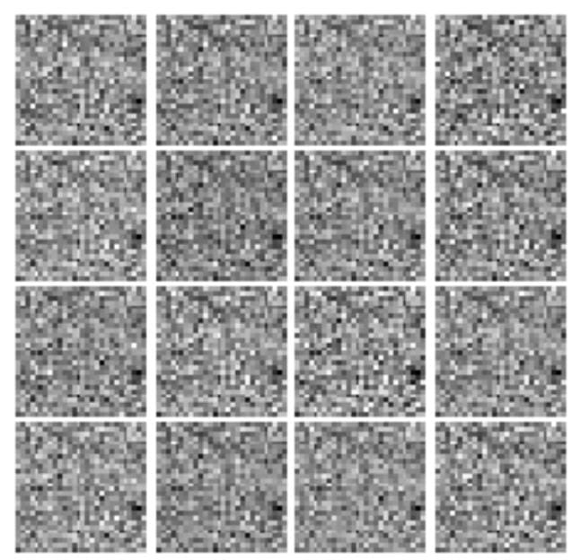

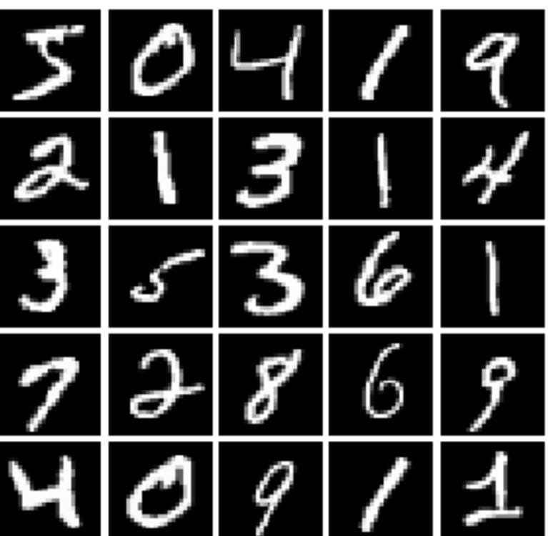

**Figure.1.2: Note Book**

CMRCET B. Tech (CSE) Page No 21

**Creating Realistic Novel Images through Generative Neural Networks (GAN)**

CHAPTER 4

**CONCLUSION**

CMRCET B. Tech (CSE) Page No 22

**Creating Realistic Novel Images through Generative Neural Networks (GAN)**

**CHAPTER 4**

**CONCLUSION**

In conclusion, the "Generative Neural Networks for Novel Image Generation" project redefines the boundaries of neural network application by embarking on a journey of creativity and imagination. The resulting images encapsulate the innovative potential of generative models, amplifying their utility across domains that celebrate artistic innovation, data augmentation, and imaginative exploration.

This project not only expands the horizons of technology but also challenges us to think creatively and responsibly about the future of AI and its impact on society. As the field of AI continues to evolve, projects like this one will continue to inspire innovation, creativity, and responsible AI development

CMRCET B. Tech (CSE) Page No 23

**Creating Realistic Novel Images through Generative Neural Networks (GAN)**

CHAPTER 5

**REFERENCES**

CMRCET B. Tech (CSE) Page No 24

**Creating Realistic Novel Images through Generative Neural Networks (GAN)**

## REFERENCES

1. <https://www.geeksforgeeks.org/generative-adversarial-network-gan/>
2. <https://en.wikipedia.org/wiki/Generative_adversarial_network>
3. <https://www.kaggle.com/code/gauravduttakiit/generative-adversarial-networks-gans/notebook#Deep-Convolutional-GANs>
4. GitHub Link:https://github.com/tejaslodaya/neural-style-transfer

## 

CMRCET B. Tech (CSE) Page No 25